**3D reconstruction**

1. Introduction

- Explain the significance and potential applications of this technology.

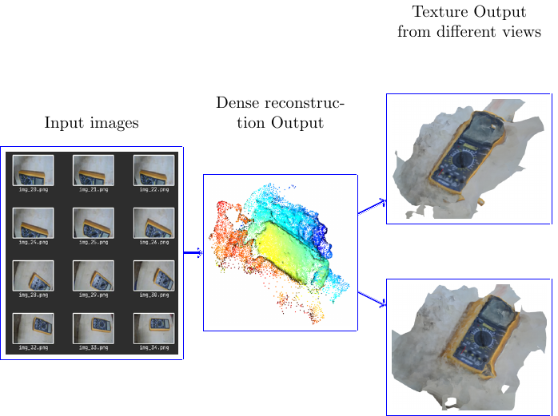

2. Methodology

"Structure from Motion" (SfM) is a computer vision technique used to reconstruct 3D structures from 2D image sequences.

- Explain the key concepts such as feature matching, bundle adjustment, and triangulation.

- Detail any specific software or libraries used for the implementation.

3. Input Data

- Discuss the type and quality of raw images used as input.

- Provide guidelines for capturing suitable images for 3D reconstruction.

4. Processing

- Explain the processing pipeline for structure from motion.

- Include any pre-processing steps, such as image alignment or normalization.

- Describe the feature extraction and matching process.

5. Output

- Showcase the 3D reconstruction results, such as point clouds or mesh models.

- Provide visual representations of the output, such as figures and diagrams.

- Discuss any metrics used to evaluate the reconstruction quality.

6. Performance Evaluation

- Include any quantitative or qualitative assessments of the reconstruction accuracy and completeness.

- Discuss any limitations or challenges encountered during the process.

7. Conclusion

- Summarize the key findings and insights from the 3D reconstruction project.

- Discuss potential areas for improvement or future work.

|  |  |  |
| --- | --- | --- |
|  |  |  |
|  |
|  |
|  |
|  |